
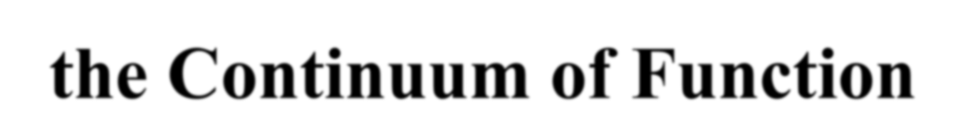
Promoting Successful Aging Across the Continuum of Function

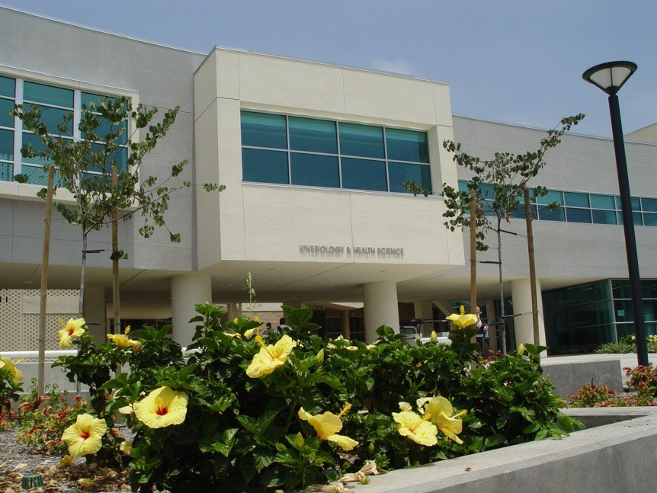

Center’s Mission
The promotion of health and vitality, and the reduction of frailty and disability in the later years……

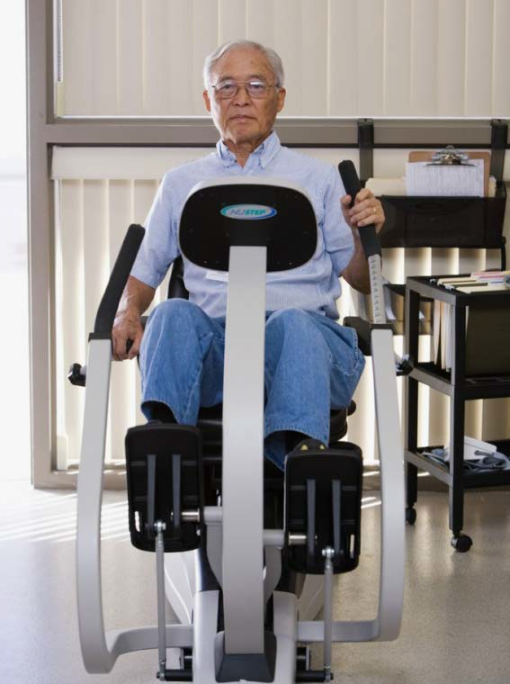
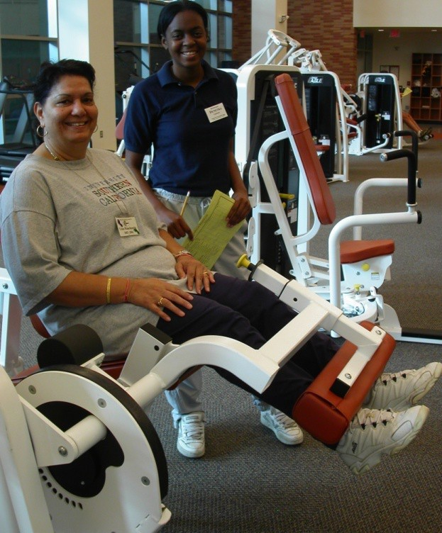
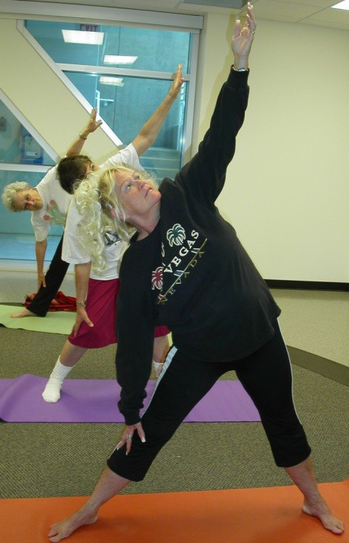

Center Facilities
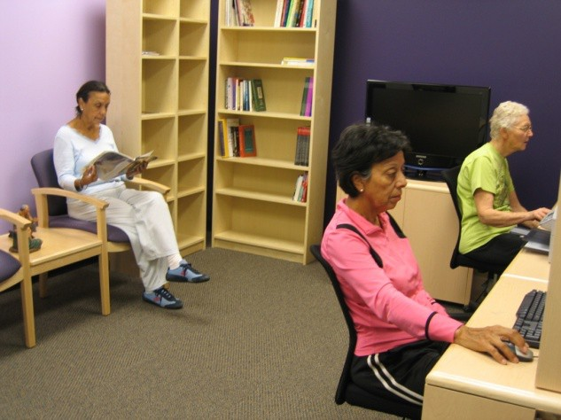
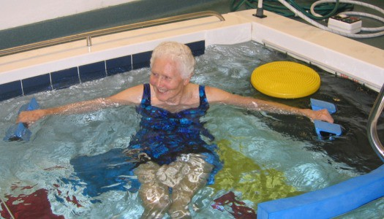
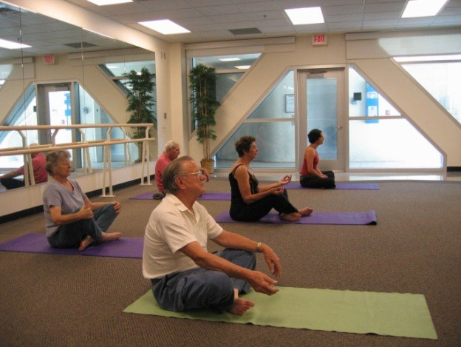
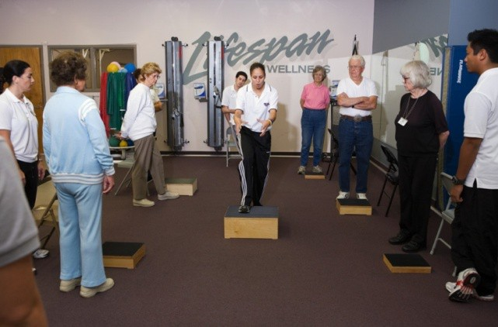
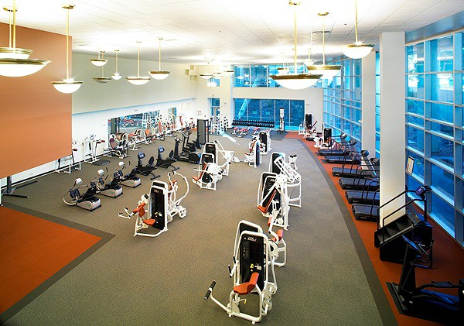

Educational Programs

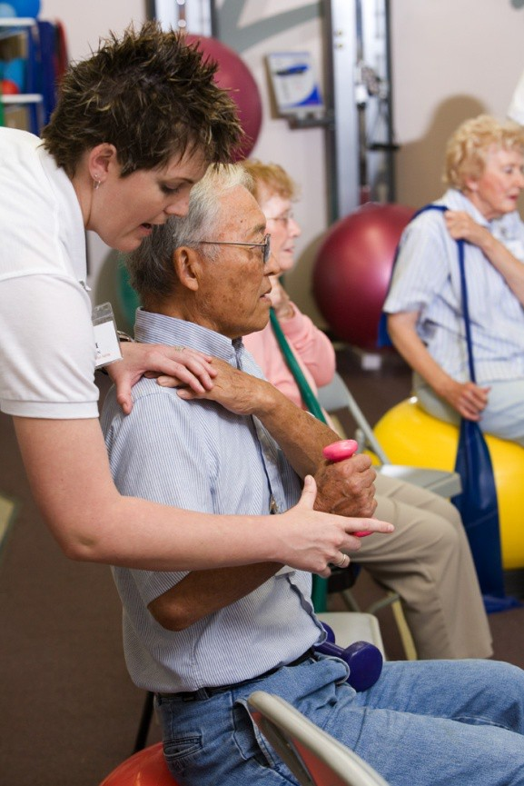
B.S. & M.S. in Kinesiology
Gerokinesiology (GK) Track

Masters in Public Health
Gerontological Health Track

Balance and Mobility Specialist Instructor Certification Program

Whole Person Wellness Workshop

Research Activities

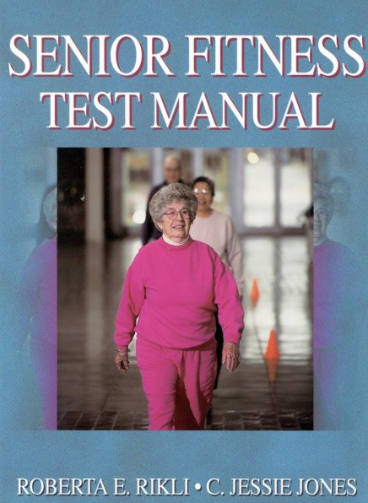
- Evaluate the long-term efficacy of the CSA Whole Person Wellness Model
- Develop and test assessment tools and programs
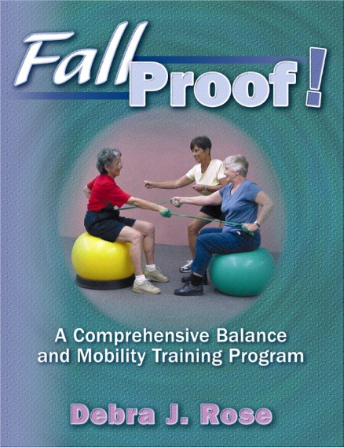
  - Fallproof
  - Better Balance
  - Stay Well at Home
  - MBA
  - InSTEP

Community Outreach Programs

Serve Two Important Purposes:
- Provide outreach to the community
- A learning laboratory for undergraduate and graduate students across disciplines

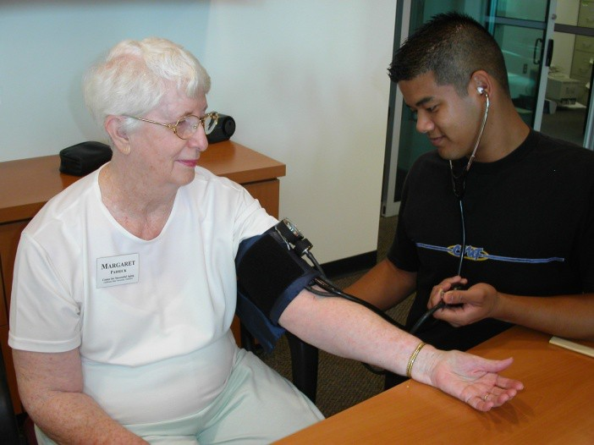
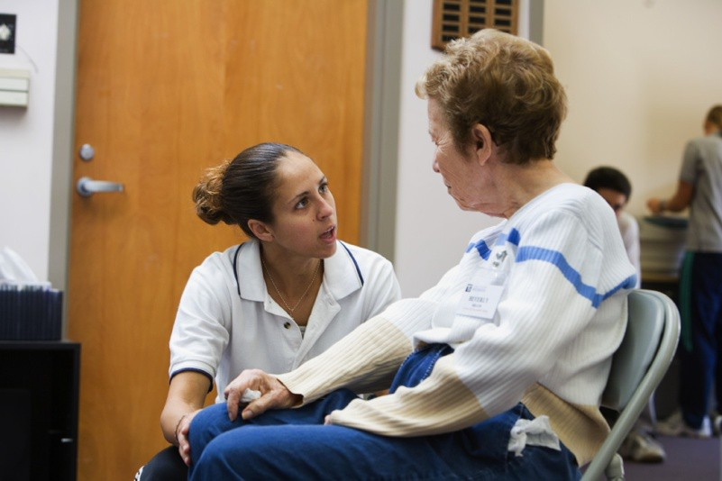
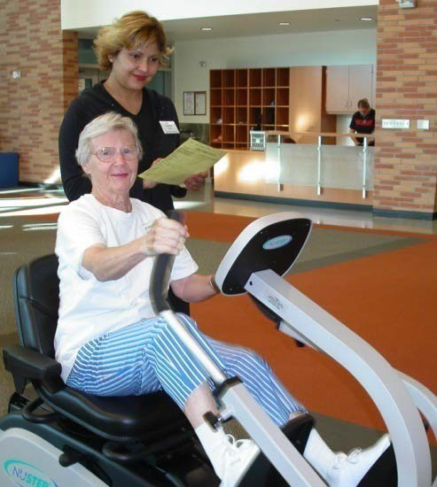

Whole Person Wellness

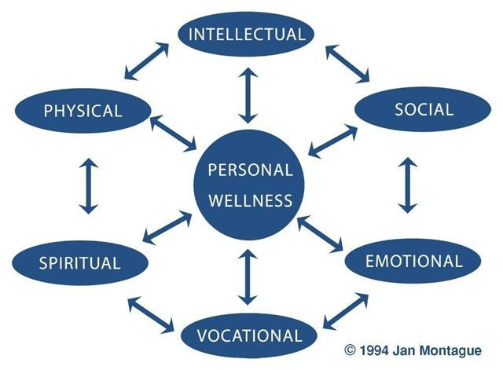


Whole Person Wellness

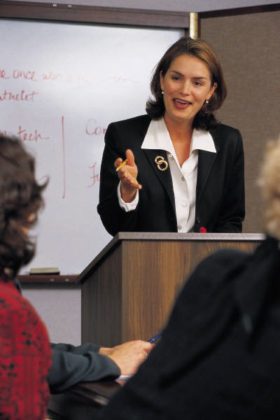
Goal setting in each dimension of wellness

Physical activity program serves as catalyst for infusing other dimensions of wellness into programming:
  - Social
  - Spiritual
  - Vocational
  - Intellectual
  - Emotional

WPW Activities
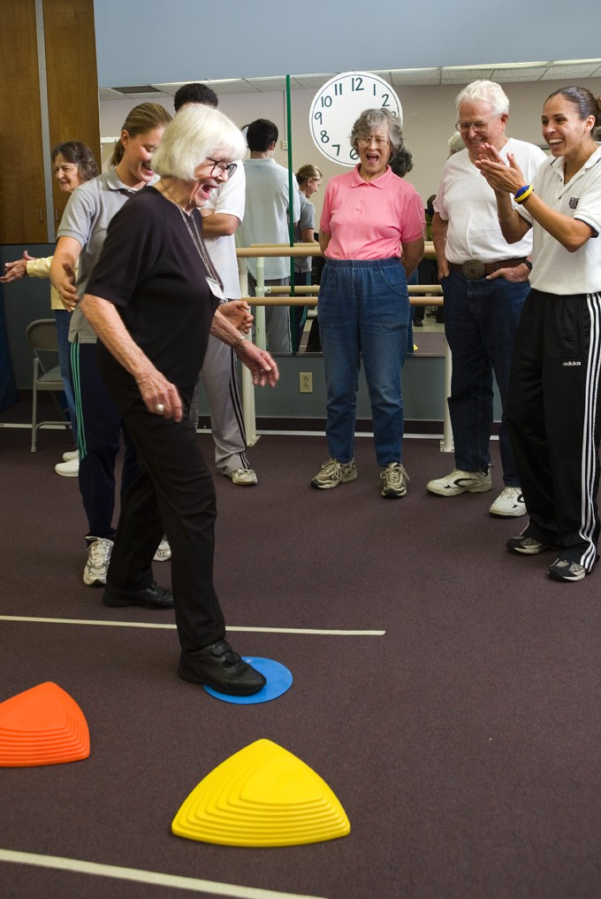
Physical Dimension:
Physical Activity Classes: Fit4Life; Balanced Fitness; Fallproof; Fallproof H₂O; Yoga
Seminars/workshops: Vision Health; Nutrition; Postural Awareness; Alexander technique; Feldenkreis

WPW Activities
- Social – ice-cream socials; random acts of kindness week; Potluck luncheons; Wii Bit of Fun
- Spiritual – meditation walks; affirmation activities
- Vocational – volunteer activities; CSA mentors and ambassadors
- Emotional – Promoting sleep using progressive relaxation; stress reduction workshops; laughter yoga; drumming
- Intellectual – Brain teasers/activities; seminars.

